Arcade machine shop

User Stories:

* As a customer, I want to choose the type of material of the machine (wood, aluminum or carbon fiber), so what I can customize my arcade machine according to my preferences and needs.
* As a customer, I want to see a list of the games available in the catalogue, so what I can choose the ones I want to include in my arcade machine.
* As a customer, I want to add games to my arcade machine using a game code, so what I can select and customize my machine with the games I prefer.
* As a customer, I want to complete the purchase of my arcade machine and provide my delivery information, so what I can complete the transaction and receive my machine at the desired address.
* As a customer, I want to search for games by category (such as action, adventure, sports, etc.), so what I can easily find games that fit my tastes and preferences.
* As a store manager, I want to have the ability to add new games to the catalog, so what the game catalog stays up to date and customers can choose from the latest available options.

Object-oriented principles análisis:

In the design of the arcade machine shop program, several SOLID principles are applied to improve the structure and maintainability of the code. The Single Responsibility Principle (SRP) is met by clearly separating the responsibilities of each class: ArcadeMachine handles machine setup, GameCatalog handles game searching, and PurchaseManager handles the purchasing process, making maintenance and maintenance easier. the evolution of software. The Open/Closed Principle (OCP) is applied, allowing the system to be extensible to add more materials or games without modifying existing classes, only adding new subclasses or expanding the catalog.

Cards CRC:

1. ArcadeMachine

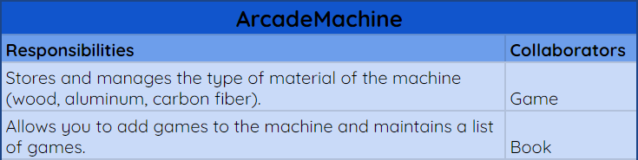

1. Game

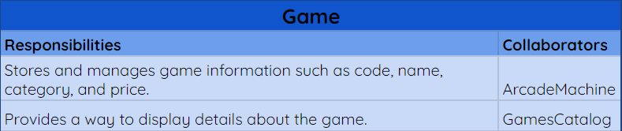

1. Customer

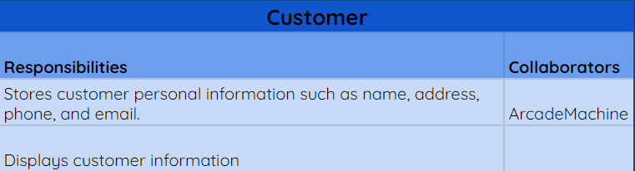

1. GameCatalog

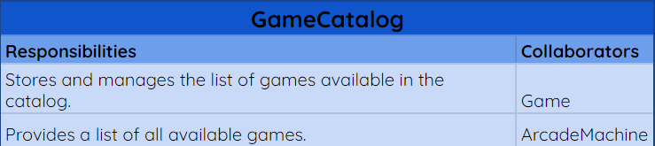

1. PurchaseManager

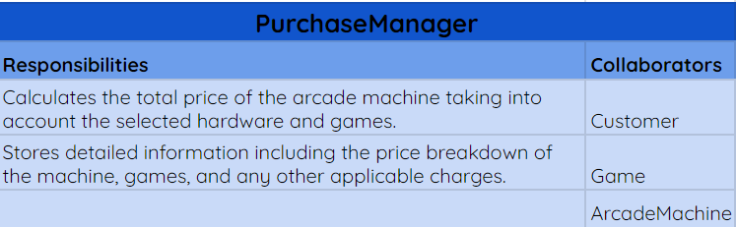

1. Admin

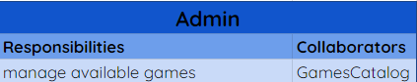

Activities Diagrams:

1. Choose material

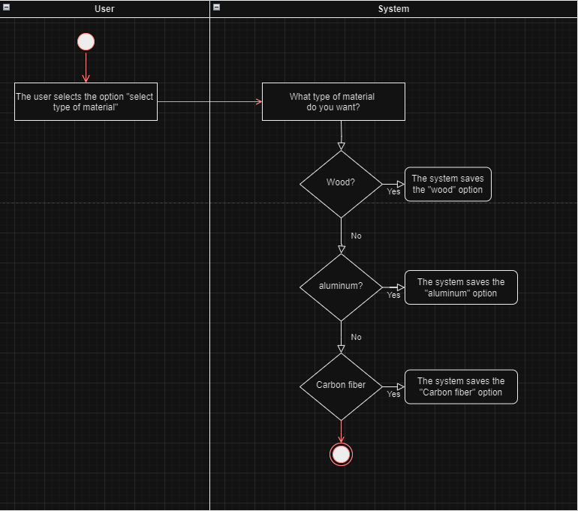

1. Show list of the games

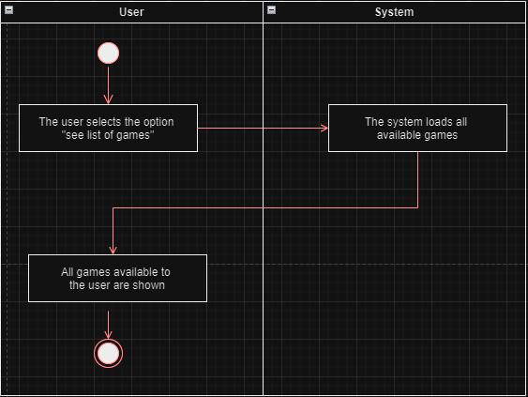

1. Add games

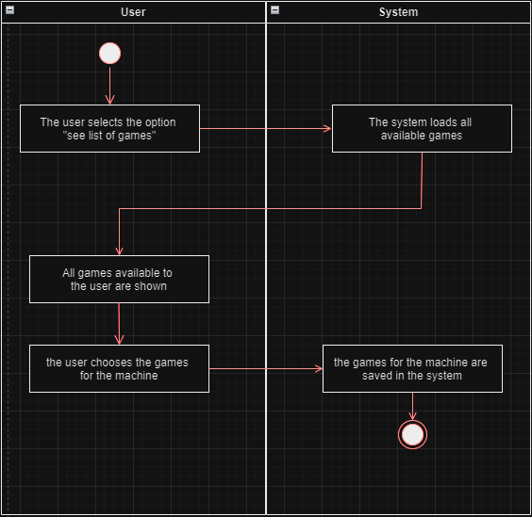

1. Buy machine

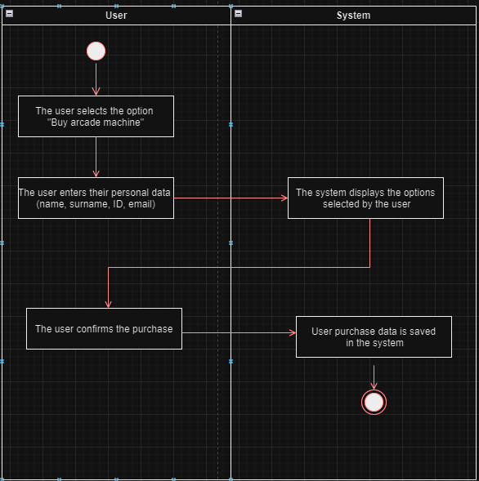

1. Search by category

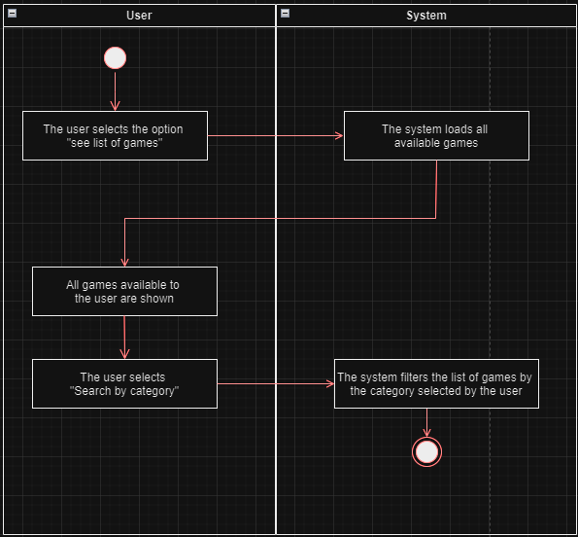

Sequence Diagrams:

1. Choose material:

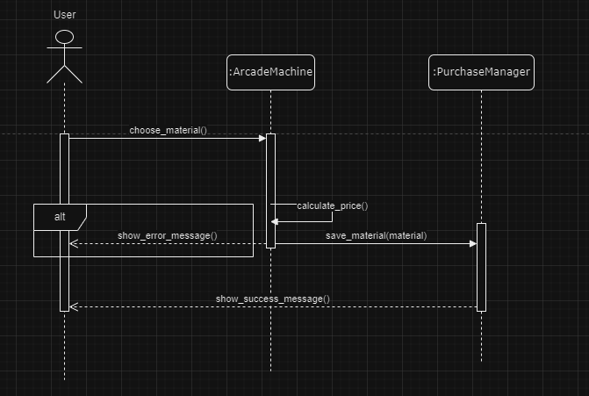

1. Show list of the games

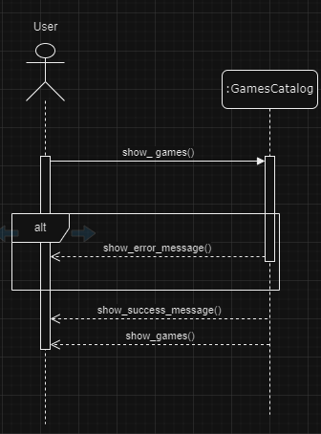

1. Add games

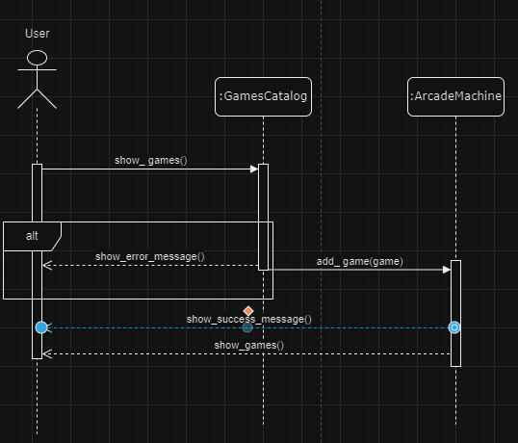

1. Buy machine

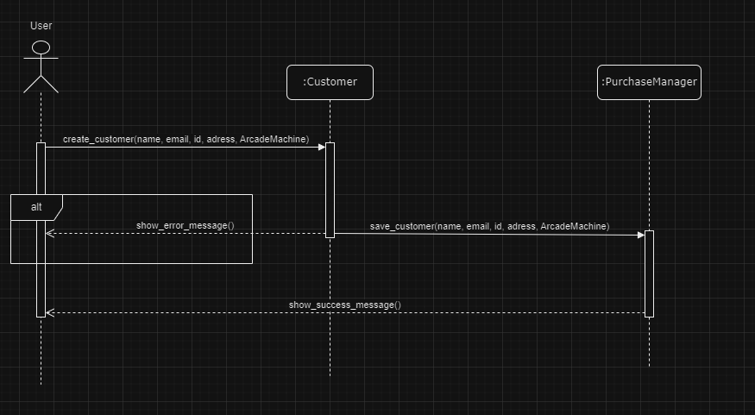

1. Search by category

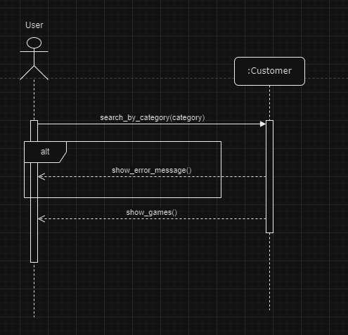

Class Diagram:

